**TECHNICAL REPORT**

**OUTLINE**

* Introduction
* Story of Data
* Data Splitting and Preprocessing
* Pre-Analysis
* In-Analysis
* Post-Analysis and Insights
* Data Visualizations & Charts
* Recommendations and Observations
* Conclusion
* Reference

1. **INTRODUCTION**

**CRIME IN WEST AFRICA**

This dataset provides a comprehensive overview of crime patterns and trends across various countries in West Africa. It includes recorded incidents of different types of crime perpetrator groups—such as boko haram, fulani extremists, separatists etc.

West Africa, a region with diverse political, social, and economic dynamics, faces unique security challenges. These include transnational organized crime, terrorism, human trafficking, and smuggling. The dataset aims to shed light on the prevalence, distribution, and evolution of these crimes to inform policy-making, law enforcement strategies, and academic research.

Key variables in the dataset  include:

* **Country**: The West African country where the data was recorded.
* **Year**: The year the crime was reported.
* **Perpetrator Type**: Group that carried out the crime, eg boko haram.0
* **Number of Fatalities**: Reported number of deaths.

This dataset  helps in identifying hotspots, emerging crime types. It is a critical tool for stakeholders working toward enhancing security, justice systems, and community resilience in West Africa. The methods used for this analysis are pivot tables.

1. **STORY OF DATA**

The data is telling a story about different crimes committed within west africa, the numbers of fatalities, injured persons and the different perpetrator group that carried out the crimes.

 The data is structured into rows and columns, rows representing country name, columns containing city, attack types, weapon types, target type, perpetrator group, fatalities and injured.

1. **DATA SPLITTING AND PROCESSING**

The data was split into two categories. Dependent values (values that can not stand on their own) and Independent values (values that can stand on their own).

**Category one : Independent values**

Country name

City

Target type

Weapon type

Perpetrator group

**Category two : Dependent values**

Fatalities

Injured

GTID

**Industry Type Of  Data**

Crime Department

**Stakeholders Of Project**

**Law enforcement**

**What success means to this industry**

Tackling the root cause of crime in west africa and putting measures to eliminate it to the lowest rate. This is what is considered as value

**4.  PRE ANALYSIS**

**Potential Analysis/Questions**

* Country with the highest perpetrator group
* City fatalities rate
* Country injured rate
* Weapon type by fatalities
* Perpetrator group by fatalities
* Count of GTID by country
* Country by fatalities rate

**5.  IN ANALYSIS**

**Analysis Observations**

* Nigeria has the highest count of GTID with a number of 5550, followed by Cameroon     with a number of 879.
* Benin has the lowest count of GTID with a number of 9.
* Nigeria was the top country with the highest rate of injured persons with a number of 12638 injured persons, followed by Chad with a number of 1867 injured persons. Benin has the lowest with a number of 9 injured persons.
* Nigeria was the top country with the highest fatalities rate with a number of 29093, followed by Cameroon with a number of 3186 fatalities. Benin has the lowest with a number of 9 fatalities.
* Maiduguri  was the peak city with the city with the highest fatalities rate with a number of 2380 fatalities, the city with the lowest fatalities rate was Damboa with a number of 506 fatalities.
* Boko haram was the top perpetrator group with a fatalities rate of 22930, followed by fulani extremities with a number of 3990 fatalities.
* Armed assault was the top weapon used in causing fatalities with a number of 15270 fatalities rates.
* 2014 was the crime peak year with the highest fatalities rate with a number of 8581 fatalities , followed by 2015 with a number of 7470 fatalities.

**In Analysis Insights**

* Benin has the lowest count of GTID and fatalities rate. Measures put in place to reduce crime rates to the minimum in Benin should be introduced to other countries in West Africa , especially in Nigeria, as Nigeria was the top country in West Africa with the highest crime rate, numbers of fatalities and injuries.
* I recommend that the government should put in place effective security measures to help eradicate the boko haram perpetrator group as they are the cause of the highest fatalities rates.
* I recommend that an army barrack be established in the city of Maiduguri , as Maiduguri was the city with the highest crime rates and fatalities. With the presence of the army in that city, law and order can be restored, the army will ensure that the tackle the root cause of crime in the city and take necessary actions to bring it to an end or reduce it to the minimum level.

**6.  POST ANALYSIS AND INSIGHTS**

**KEY FINDINGS;**

YEARS:

2014 was the crime peak year with the highest fatalities rate of 8581 fatalities. Nigeria was the top country in 2014 with the highest injury rate of 2283 persons and highest fatalities with a number of  7775, Cameroon has a number of 20 injured persons and 789 fatalities, Niger has a number of 9 injured persons, 11 fatalities, Ghana has a number of 3 injured persons and 0 fatality, Chad has a number of 0 injured person and 6 fatalities.

Top perpetrator group by fatalities rate in 2014 was the boko haram group with a total number of 6558 fatalities rates.

2015:

2015 has a total fatalities rate of 7470 fatalities. Nigeria was the top country in 2015 with the highest injury rate of 2863 persons and highest fatalities with a number of  5567, Cameroon has a number of 463 injured persons and 931 fatalities, Niger has a number of 116 injured persons, 666 fatalities,  Chad has a number of 427 injured persons and 306 fatalities.

Top perpetrator group by fatalities rate in 2015 was the boko haram group with a total number of 6222 fatalities rates.

2018:

2018 has a total fatalities rate of 3062 fatalities. Nigeria was the top country in 2018 with the highest injury rate of 1005 persons and highest fatalities with a number of  2577, Cameroon has a number of 224 injured persons and 296 fatalities, Niger has a number of 71 injured persons, 75 fatalities, Ghana has a number of 5 injured person and 2 fatalities, Chad has a number of 13 injured persons and 112 fatalities.

Top perpetrator group by fatalities rate in 2018 was the boko haram group with a total number of 1290 fatalities rates.

2020:

2020 has a total of 2931 fatalities. Nigeria was the top country in 2020 with the highest injury rate of 801 persons and highest fatalities with a number of  2102, Cameroon has a number of 180 injured persons and 209 fatalities, Niger has a number of 124 injured persons, 371 fatalities, Ghana has a number of 12 injured persons and 4 fatalities, Chad has a number of 117 injured persons and 244 fatalities, Benin has a total of 1 injured person and 1 fatality.

Top perpetrator group by fatalities rate in 2020 was the boko haram group with a total number of 1848 fatalities rates.

CITY:

Maiduguri was the crime peak city  by fatalities rate, with a number of 2380 fatalities. 2015 was the year with the highest fatalities rate in Maiduguri with a number of 611 fatalities.

Bombing/Explosion was the top weapon type that was used for crime and resulted to the highest fatalities rates with a number of 1040 fatalities.

The top perpetrator group in Maiduguri was the boko haram group with a total number of 1639 fatalities.

CITY:

Unknown has a total fatalities rate of 1209 fatalities.

Armed assault was the top weapon type that was used for crime and resulted to the highest fatalities rates with a number of 865 fatalities.

The top perpetrator group by fatalities rate was the boko haram group with a total number of 545 fatalities.

CITY:

Kano has a total fatalities rate of 644 fatalities.

Bombing/Explosion, Armed assault was the top weapon type that was used for crime and resulted in the highest fatalities rates with a number of 297 fatalities.

The top perpetrator group by fatalities rate in Kano was the boko haram group with a total number of 435 fatalities.

Year 2012 was the year with the highest fatalities rate in Kano with a number of 288 fatalities.

CITY:

Konduga has a total fatalities rate of 642 fatalities. 2014 was the year with the highest fatalities rate in Konduga with a number of  444 fatalities.

Armed assault was the top weapon type that was used for crime and resulted in the highest fatalities rates with a number of 395 fatalities.

The top perpetrator group in Konduga was the boko haram group with a total number of 579 fatalities.

CITY:

Damboa  was the crime city with the lowest fatalities rate, with a number of 506 fatalities. 2014 was the year with the highest fatalities rate in Damboa with a number of 320 fatalities.

Armed assault was the top weapon type that was used for crime and resulted to the highest fatalities rates with a number of 453 fatalities.

The top perpetrator group in Damboa was the boko haram group with a total number of 465 fatalities.

COUNTRY:

Nigeria

The top country in West Africa with the highest fatalities and injured rates was Nigeria with a total number of 29093 fatalities and 12638 injured persons.

Top perpetrator group was the boko haram with a number of 18205 fatalities.

Top weapon used was armed assault with a number of 12277 fatalities.

Count of GTID was 5550.

COUNTRY:

Cameroon

The total number of  fatalities was 3186 and injured persons was a total number of 1642.

Top perpetrator group was the boko haram with a number of 2509 fatalities.

Top weapon used was armed assault with a number of 1048 fatalities.

Count of GTID was 879.

COUNTRY:

Niger

The total number of  fatalities was 2284 and injured persons was a total number of 751.

Top perpetrator group was the boko haram with a number of 1349 fatalities.

Top weapon used was armed assault with a number of 1257 fatalities.

Count of GTID was 257.

COUNTRY:

Chad

The total number of  fatalities was 1664 and injured  persons was a total number of  1867.

Top perpetrator group was the boko haram with a number of 867 fatalities.

Top weapon used was armed assault with a number of 676 fatalities.

Count of GTID was 132.

COUNTRY:

Ghana

The total number of  fatalities was 27 and injured persons was a total number of 35.

Top perpetrator group was an unknown group with a number of 20 fatalities.

Top weapon used was armed assault with a number of 11 fatalities.

Count of GTID was 34.

COUNTRY:

Benin

It was the country in West Africa with the lowest crime rate, with a total number of 3 fatalities and 9 injured persons.

Top perpetrator group was an unknown group with a number of 1 fatality.

Top weapon used was hostage taking(kidnapping), armed assault with a number of 1 fatality.

Count of GTID was 10.

WEAPON TYPES:

Armed assault

It was the top weapon type used in crimes with the highest fatalities rates, with a number of 15270 fatalities, used mainly by the boko haram perpetrator group.

 Followed by armed assaults, facility/infrastructure attack with a number of 6300 fatalities, Bombing/Explosion with a number of 5905 fatalities and lastly unknown weapon type with a number of 2512 fatalities.

**7. DATA VISUALIZATION AND CHARTS**

**DASHBOARD**

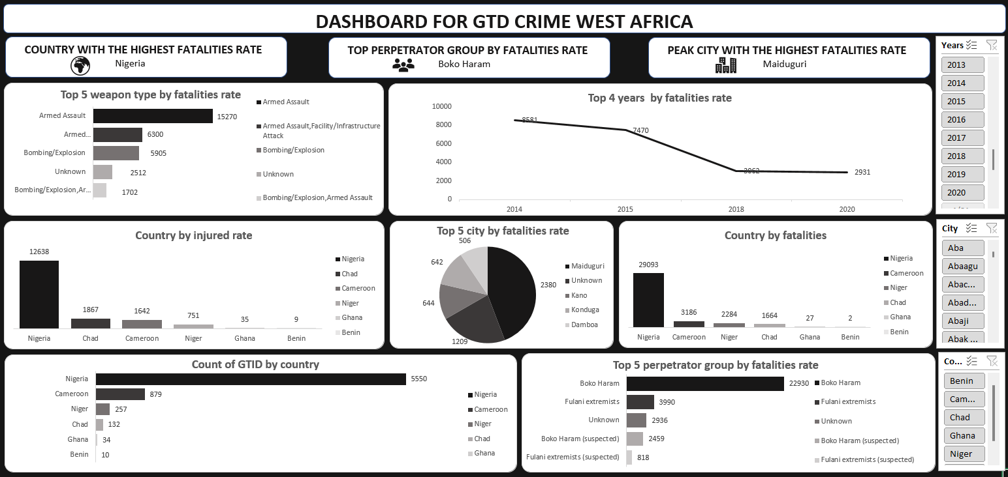

**CHARTS**

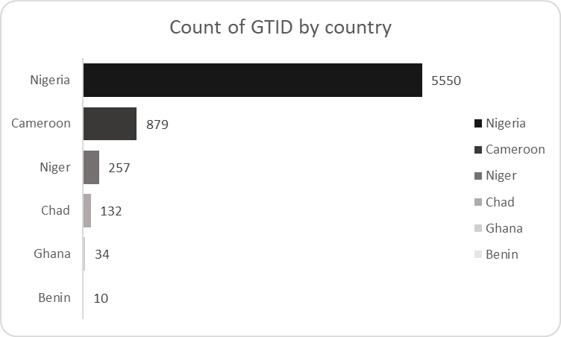

This bar chart shows the count of GTID by country showing Nigeria with the highest count of 5550, followed by Cameroon with a count of 879. Benin had the lowest count of 10.

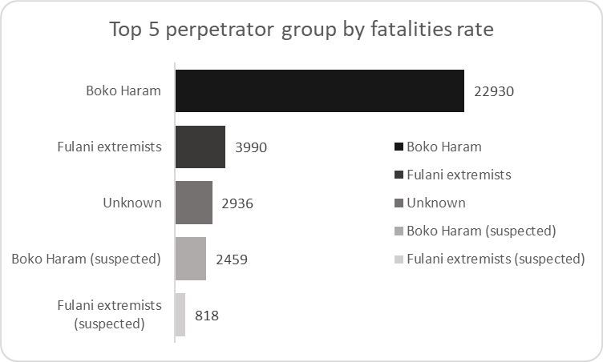

This bar chart shows the top 5 perpetrator groups by fatalities rate, showing boko haram as the top perpetrator group with the highest fatalities rate of 22930.

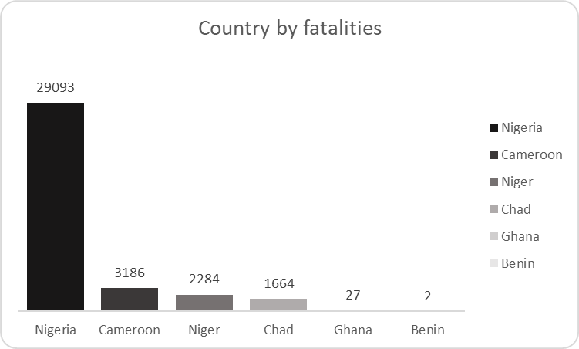

This column chart shows the top 5 countries by fatalities, showing Nigeria as the country in West Africa with the highest fatalities with a number of 29093, followed by Cameroon with a number of 3186. Benin had the lowest.

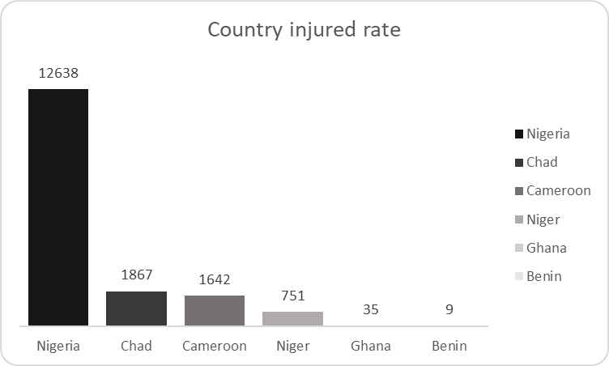

This column chart shows the top 5 countries by injured rate, showing Nigeria as the country with the highest injury rate with a number of 12638, followed by Chad with a number of 1867.

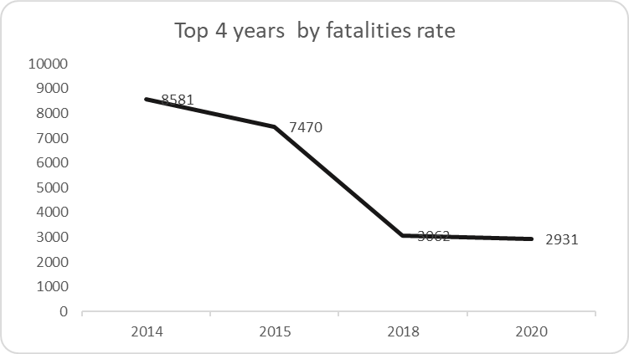

This line chart shows the top 4 years by fatalities rate showing 2014 as the year with the highest fatalities rate, there was a decrease in the number of fatalities from 2014-2020, making 2020 the year with the lowest fatalities rate.

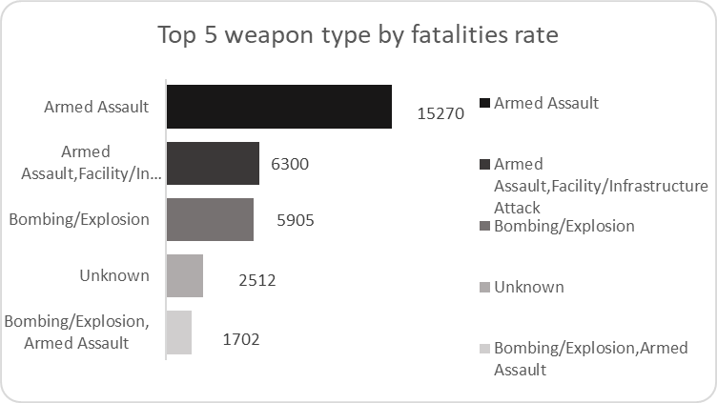

This bar chart shows the top 5 weapon types by fatalities rate, showing armed assault as the top weapon type with a fatality rate of 15270.

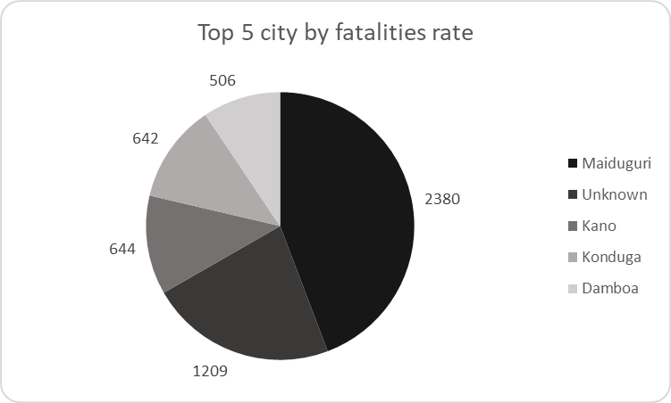

The pie chart shows the top 5 cities by fatalities, showing Maiduguri has the top city with the highest fatalities rate with a number of 2380.

**8.  OBSERVATIONS AND RECOMMENDATIONS**

As a data analyst examining crime trends across West Africa, it is evident that the region faces multifaceted security challenges, ranging from organized crime and armed conflicts to urban violence. These issues not only threaten public safety and national stability but also hinder economic growth and social development.  To combat crime in West Africa especially in region like Nigeria with high fatalities and crime rate, i do recommend the following measures:

* Increase funding for security forces to ensure they have modern equipment, proper training, and welfare incentives.
* Improve intelligence gathering by enhancing cyber-surveillance, using drones, and increasing informant networks.
* Enhance inter-agency cooperation among the police, military, DSS (Department of State Services), and other security agencies.
* Enhance inter-agency cooperation among the police, military, DSS (Department of State Services), and other security agencies.
* Establish community policing programs to strengthen ties between law enforcement and local communities.
* Implement strict accountability measures to eliminate corruption within security agencies.
* Increase recruitment into the police and military to address understaffing issues.
* Enforce harsher penalties for violent crimes like murder, kidnapping, and armed robbery.
* Create more job opportunities through industrialization, agriculture, and entrepreneurship programs.
* Increase access to education, especially in the North, to reduce the number of youths vulnerable to crime and radicalization.
* Provide vocational training and skill acquisition programs to empower young people with employable skills.
* Expand microfinance programs to support small businesses and reduce poverty.
* Enhance border surveillance to prevent illegal arms smuggling and terrorist infiltration. Use biometric registration and monitoring for all foreigners entering Nigeria.
* Increase patrols along porous borders and establish more checkpoints in high-risk areas.
* Work with neighboring countries to share intelligence and combat cross-border crimes.
* Increase military presence in the North-East (especially in Maiduguri) and conduct regular operations to dislodge terrorists. Use drone and satellite technology for real-time tracking of terrorist movements.
* Enhance psychological warfare campaigns to discourage Boko Haram recruitment. Encourage defectors and reintegration programs for former Boko Haram members willing to surrender.
* Improve education and counter-extremism programs to prevent radicalization in vulnerable communities.
* Work closely with international partners to share intelligence and gain military support.
* Install CCTV cameras in major cities to monitor and deter criminal activities.
* Support local vigilante groups with training, funding, and equipment while regulating their operations.
* Encourage neighborhood watch programs where residents actively report suspicious activities.
* Use traditional rulers and religious leaders to mediate conflicts and prevent radicalization.
* Promote inter-ethnic and inter-religious dialogue to prevent violence caused by ethnic tensions.
* Regulate motorcycle and tricycle operations to prevent their use in crimes like robbery and kidnapping.
* Use AI and big data analytics to predict and prevent criminal activities.  Encourage citizens to report crimes anonymously through mobile apps or hotlines.
* Speed up the judicial process to ensure quick trials and fair judgments for criminal offenses. Implement strong witness protection programs to encourage people to testify against criminals.

**9.  CONCLUSION**

In conclusion, crime reduction in West Africa requires a multi-faceted approach involving security, legal reforms, socio-economic development, and community engagement. Addressing the root causes of crime—**poverty, unemployment, corruption, and weak law enforcement**, will ensure long-term success in making West Africa  a safer place.

**10.  REFERENCE**

The dataset was gotten from  [https://www.kaggle.com](https://www.kaggle.com/)/